**CASE STUDY**

**Name: Sahithi Gonuguntla**

**Github Link:** <https://github.com/sahithi517/Unextcasestudy>

**Create Virtual Machine:**

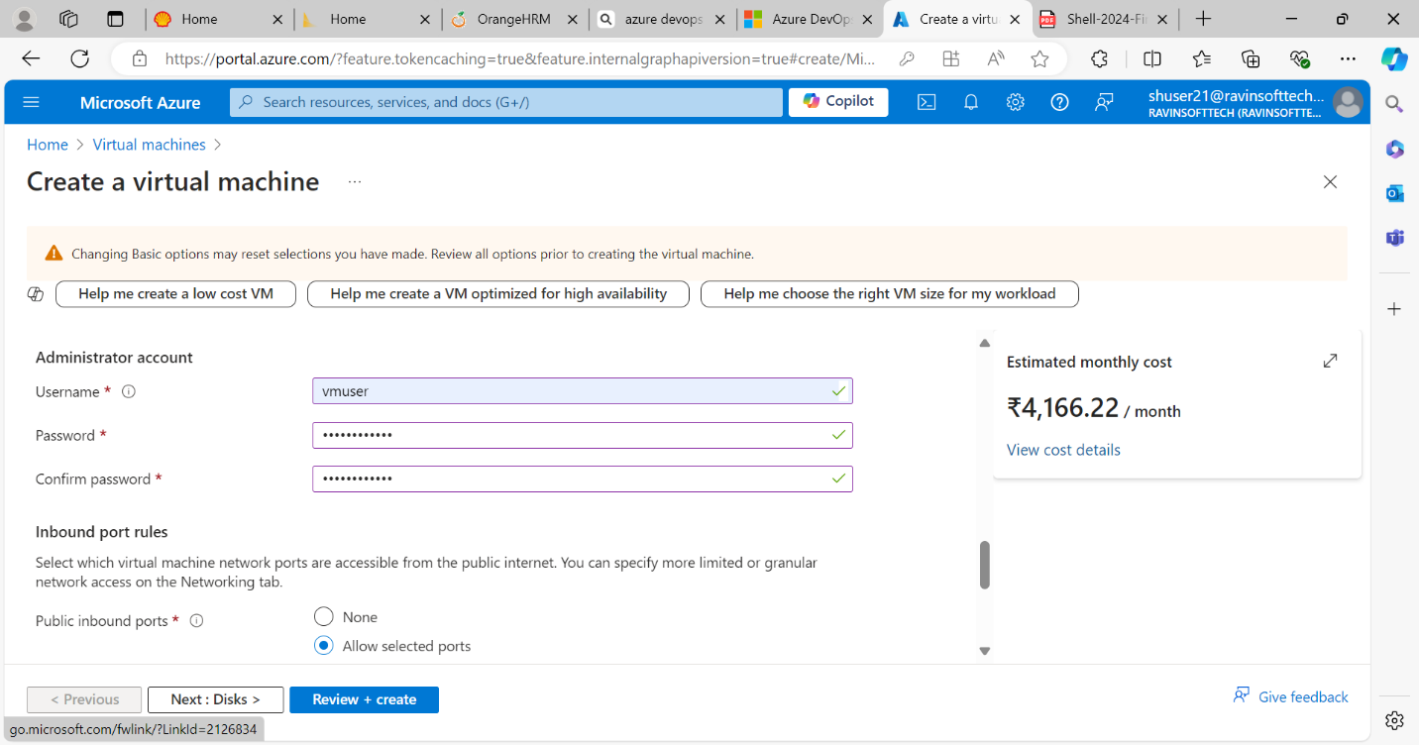

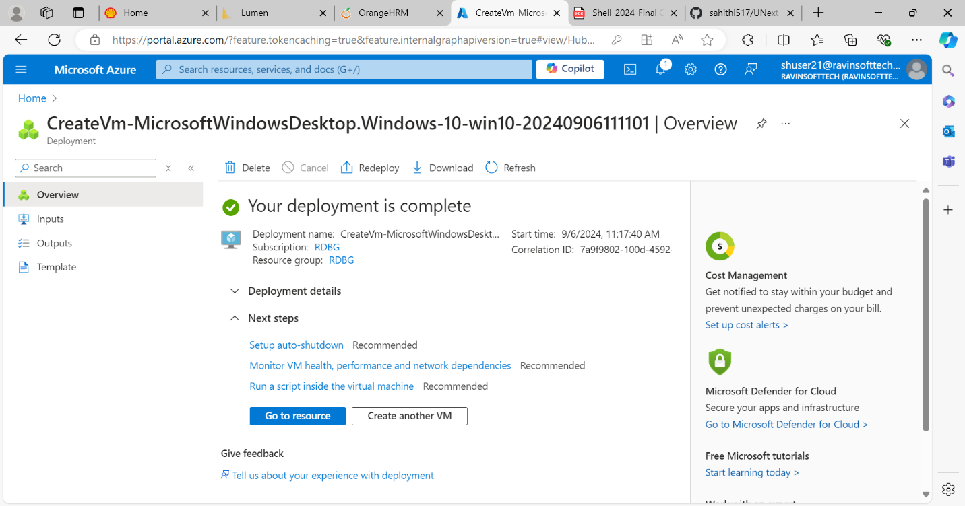

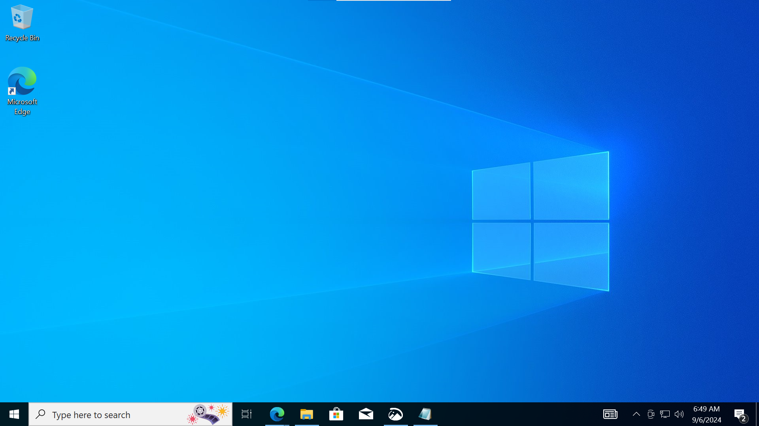

**Azure Devops**

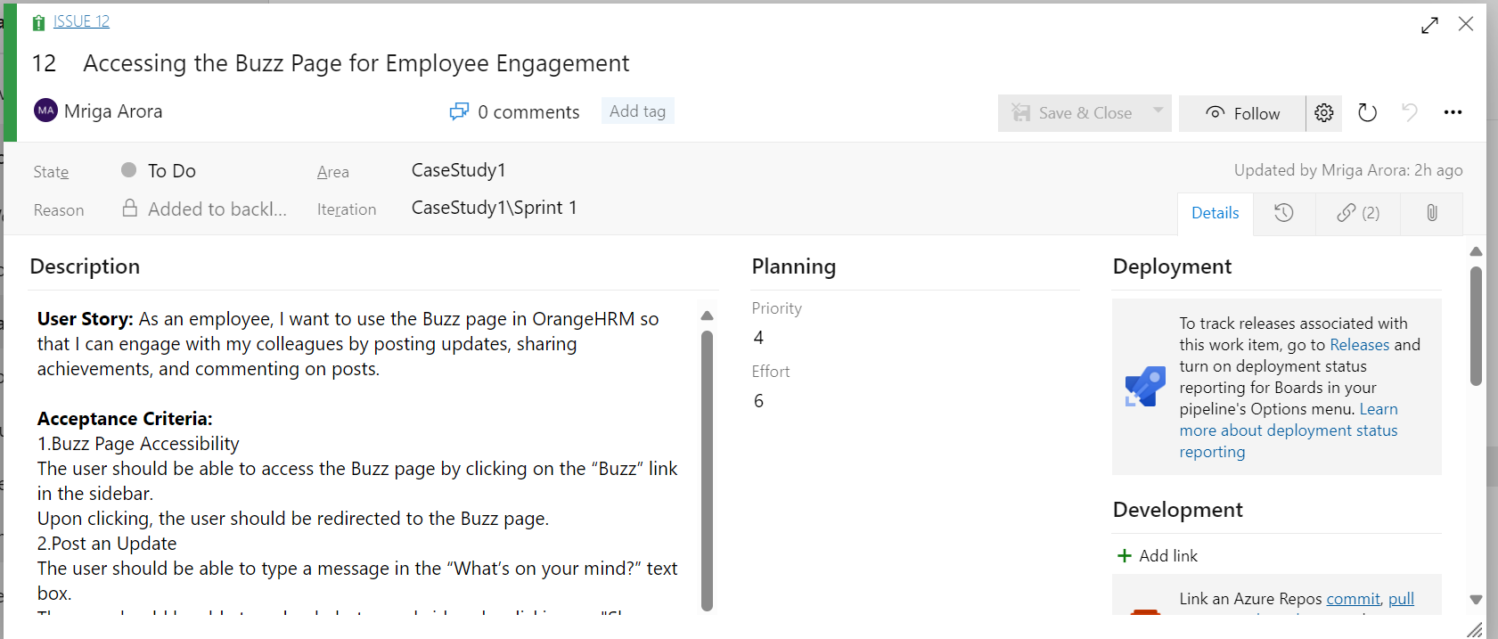

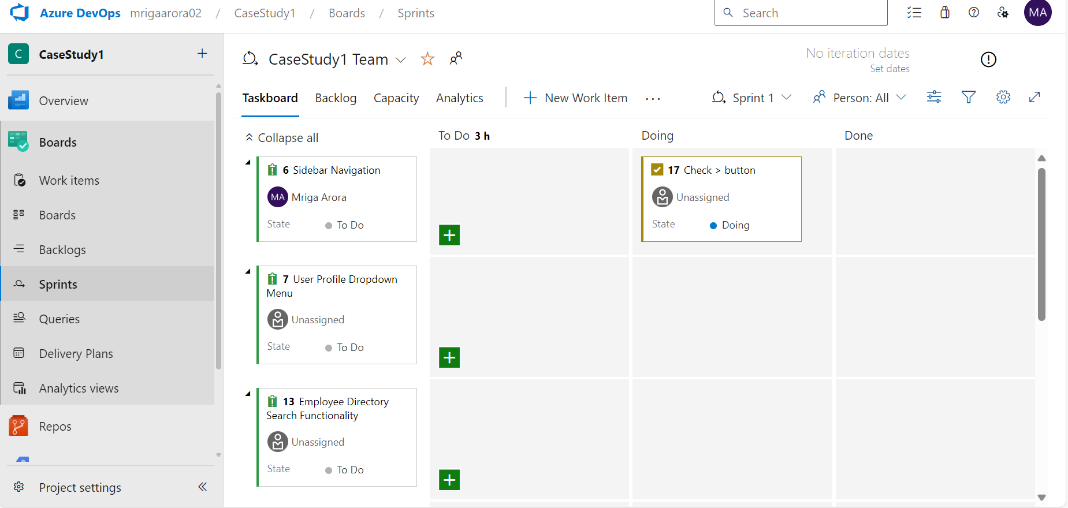

**Github :**

Github Link: <https://github.com/sahithi517/Unextcasestudy>

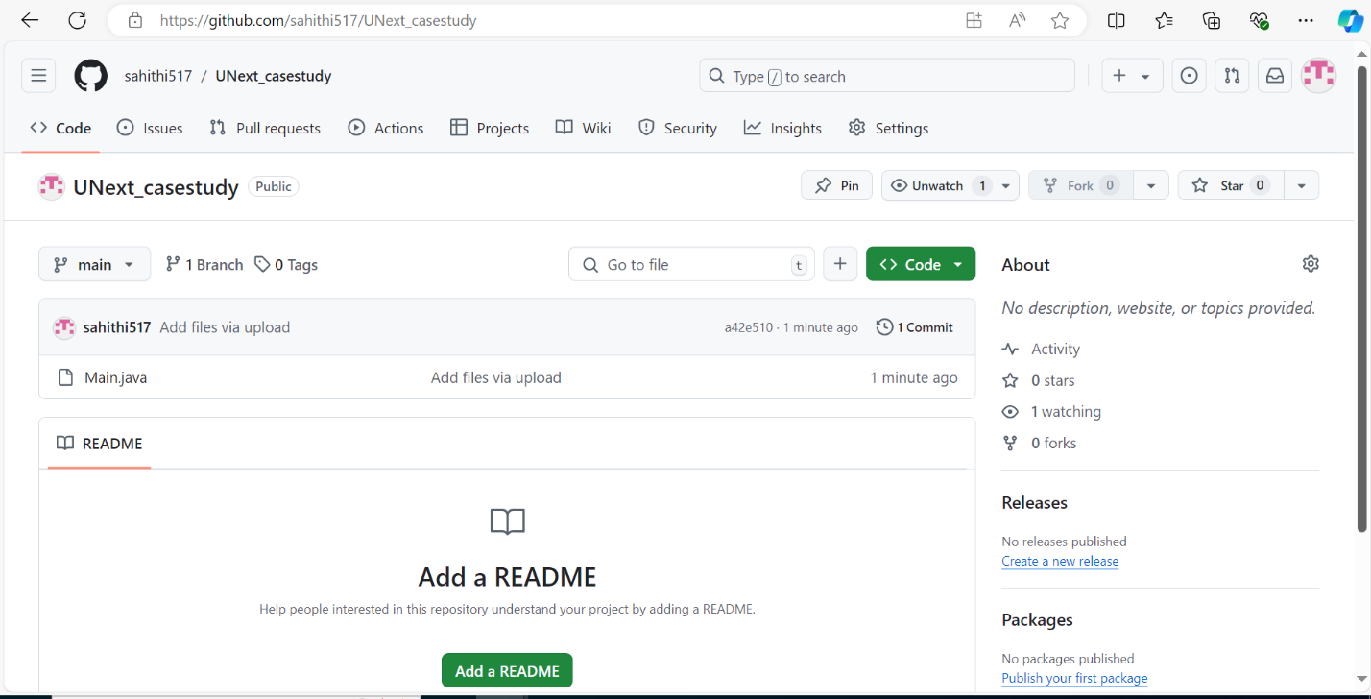

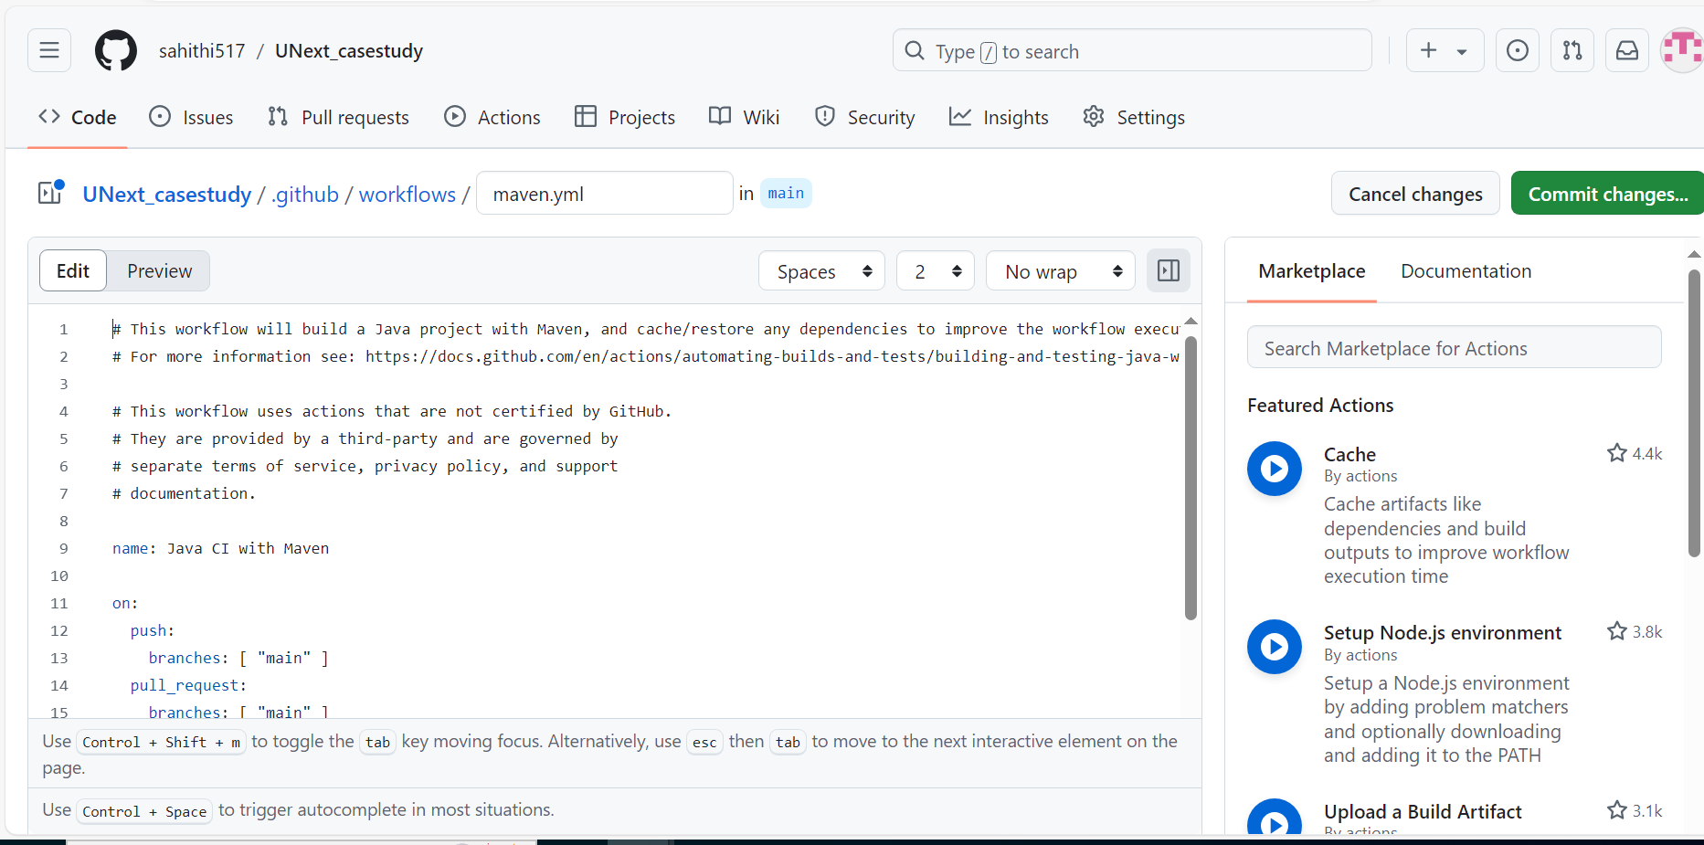

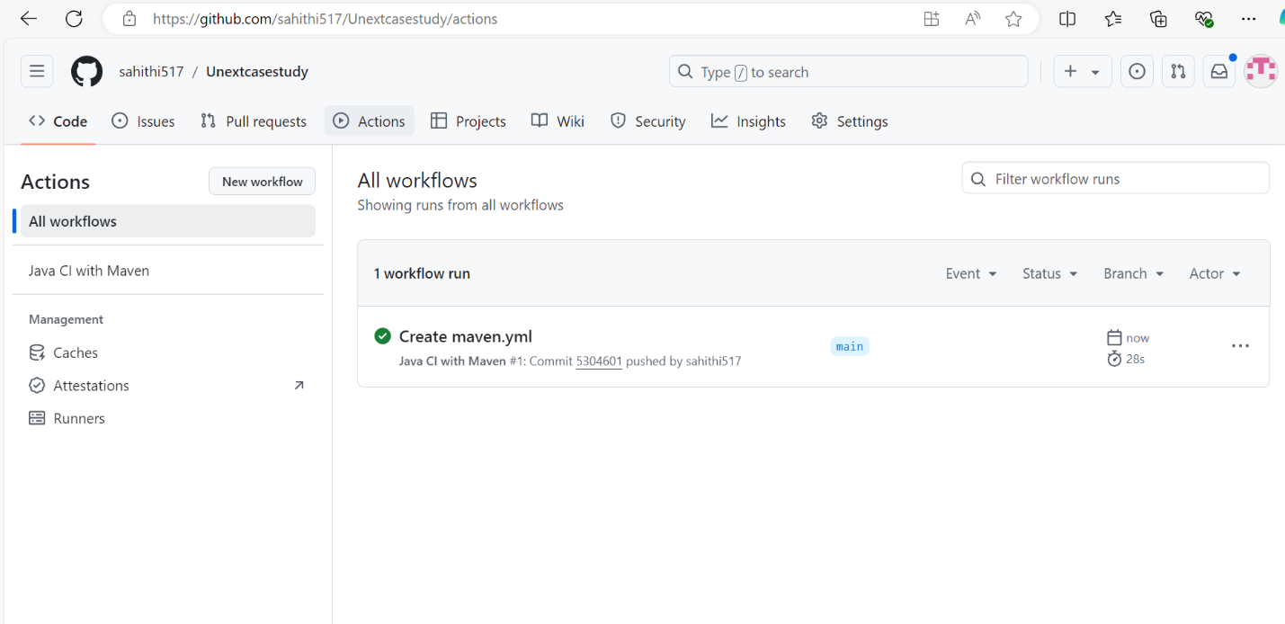

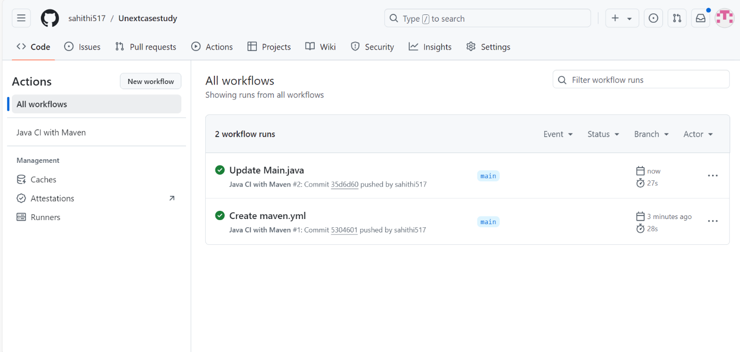

**User Stories:**

**1)Accessing Help resources from home page**

**Description:**

As a user of the OrangeHRM website,

When I click on help button, I should be able to access help resources.

**Acceptance Criteria:**

1 The question mark icon should be visible on the dashboard's top-right corner.

2 When the user clicks on the question mark icon, it should open a new page displaying the help resources.

3 The help resources page should contain sections such as "Admin User Guide," "Employee User Guide," "Mobile App," "AWS Guide," and "FAQs."

4 A search bar should be present on the help resources page to allow users to search for specific topics.

**Estimation**: 4

**priority**: 4

**Test Cases:**

**Test case 01**-: Visibility of the Help Icon on the Dashboard

Given the user is logged into the OrangeHRM system

When the user navigates to the dashboard

Then the help icon (question mark) should be visible in the top-right corner of the page

**Test case 02**- Redirection to Help Resources Page

Given the user is on the OrangeHRM dashboard

When the user clicks on the help icon (question mark)

Then the system should open the help resources page

**Test case 03**- Verify Help Resources Page Sections

Given the user is on the help resources page

Then the page should contain sections:

1) Admin User Guide

2) Employee User Guide

3) Mobile App

4) AWS Guide

5) FAQs

**Test case 04**- Search Functionality on Help Resources Page

Given the user is on the help resources page

When the user enters "Leave Policy" in the search bar

And the user clicks the search button

Then relevant results for "Leave Policy" should be displayed

**Test case 05-** Functional Links on Help Resources Page

Given the user is on the help resources page

When the user clicks on any section (e.g., "Admin User Guide," "Employee User Guide")

Then the system should navigate to the selected section's detailed page

**2)Accessing Admin User Management from Dashboard**

**Description:**

As an admin user of OrangeHRM website,

I want to access the user management page from the dashboard,

so that I can manage system users efficiently.

**Acceptance Criteria:**

1 The admin icon should be visible in the sidebar of the dashboard.

2 When the admin clicks on the icon, it should open the "Admin/User Management" page.

3 The "Admin/User Management" page should display filters such as:

◦ Username

◦ User Role

◦ Employee Name

◦ Status

4 The admin should be able to filter users by inputting values into the search fields and pressing the "Search" button.

5 The system should display the filtered user results below the search fields, showing relevant information such as Username, User Role, Employee Name, and Status.

6 The admin should have the ability to reset the search criteria by pressing the "Reset" button.

7 The admin should be able to add new users by clicking the "+ Add" button.

**Estimation:** 5

**Priority**: 1

**Test Cases:**

**Test case 06**- Visibility of admin Icon

Given the user is logged in as an "Admin"

When the user is on the dashboard page

Then the admin icon should be visible in the sidebar

**Test case 07**- Navigation to Admin/User Management Page

Given the user is logged in as an "Admin"

When the user clicks on the admin icon in the sidebar

Then the system should navigate to the "Admin/User Management" page

**Test case 08**- Filters Display on Admin/User Management Page

Given the user is on the "Admin/User Management" page

Then the page should display the following filters:

1) Username

2) User Role

3) Employee Name

4) Status

**Test case 09**- Filtering Users

Given the user is on the "Admin/User Management" page

When the user enters values in the filters (Username, User Role, Employee Name, Status)

And the user clicks on the "Search" button

Then the system should display filtered results showing relevant information such as Username, User Role, Employee Name, and Status

**Test case 10**- Reset Search Criteria

Given the user has entered search criteria on the "Admin/User Management" page

When the user clicks on the "Reset" button

Then the search fields should be cleared

**Test case 11**- Adding New Users

Given the user is on the "Admin/User Management" page

When the user clicks the "+ Add" button

Then the system should navigate to the "Add New User" page

And the admin should be able to input details for creating a new user

**Test case 12-** Deleting User

Given the admin is on the "Admin/User Management" page

And the admin has filtered a user from the search results

When the admin clicks the "Delete" button for the specific user

Then the system should remove the user and display a success message

**3) Login Page**

**Description:**

As a user, I should be directed to the Login page upon clicking the application URL. In the Login page, the username and password fields should be available to enter my credentials. A login button should be present to submit the credentials and a ‘forgot your password’ link should be enabled.

**ACCEPTANCE CRITERIA:**

Both the username and password fields should be editable, and the login button should be clickable. The ‘forgot password’ link should be clickable to reset the password.

**Estimation:** 5

**Priority**: 1

Test Case:

**Test Data**

|  |  |
| --- | --- |
| Valid USERNAME | Admin |
| Valid PASSWORD | admin123 |

**Test Cases:**

**Test case 13**- To check whether the user can enter credentials

Given the user is able to access the OrangeHRM website (<https://opensourcedemo.orangehrmlive.com/web/index.php/auth/login>).

When user clicks on the “username” and “password” fields  
Then user should be able to type the username and password.

**Test case 14**- To check whether the password field is masked

Given the user is able to access the OrangeHRM website (<https://opensourcedemo.orangehrmlive.com/web/index.php/auth/login>).

When user clicks on the “password” field

And starts typing the password  
Then the password should be displayed as masked (i.e. dots)

**Test case 15**- check with Valid username and Valid password

Given the user is able to access the OrangeHRM website (<https://opensourcedemo.orangehrmlive.com/web/index.php/auth/login>).

When user enters valid username and password

And clicks on the login button  
Then user should be redirected to the Dashboard page.

**Test case 16**- check with invalid credentials

Given the user is able to access the OrangeHRM website (<https://opensourcedemo.orangehrmlive.com/web/index.php/auth/login>).

When user enters invalid username and valid password / valid username and invalid password/ invalid username and invalid password

Then ‘Invalid credentials’ message should appear.

**Test case 17-** To check whether the Login button works properly

Given the user enters valid username and password

When the user clicks on the Login button  
Then user should be redirected to the Dashboard page.

4)**BUZZ Page**

**Description:**

As an employee, I want to use the Buzz page in OrangeHRM so that I can engage with my colleagues by posting updates, sharing achievements, and commenting on posts.

**Acceptance Criteria:**

1.Buzz Page Accessibility

The user should be able to access the Buzz page by clicking on the “Buzz” link in the sidebar.

Upon clicking, the user should be redirected to the Buzz page.

2.Post an Update

The user should be able to type a message in the “What’s on your mind?” text box.

The user should be able to upload photos and videos by clicking on "Share photos" or "Share videos

Clicking the “Post” button should add the message to the Buzz feed, making it visible to all employees.

3.Like a Post

The user should be able to click the “Heart” icon on any post to like a post.

The like count on the post should increment, and the post should indicate that the user has liked it.

4.Comment on a Post

The user should be able to click the “Comment” icon on any post to comment on it.

After typing a comment and clicking “Submit,” the comment should be added to the post and visible to all employees.

5. Share a post

The user should be able to click "Share" icon to share it under their name.

5.View Post Details

The user should be able to click on any post to view its details.

The post details should include all comments, likes and shares.

6.Delete Own Post

The user should have the option to delete their own posts.

Clicking the “Delete” button on their post should remove it from the Buzz feed.

7.Edit Own Post

The user should have the option to edit their own posts.

Clicking the “Edit” button, making changes, and saving should update the post with the new content.

Notification for New Posts

Users should receive notifications when new posts are made on the Buzz page.

8.Search Posts

The user should be able to search for posts using a keyword.

The Buzz feed should display posts that match the keyword entered in the search bar.

9.Filter Posts by likes, comments and date.

The user should be able to filter posts by likes, comments or most recent by clicking either "Most Liked Posts", "Most commented Posts", or "Most recent Posts" respectively. displayed on the top.

The Buzz feed should display posts made within the file.

**Test Cases**

**Test case 17-** Buzz Page Accessibility

Given The user is logged into OrangeHRM. When The user clicks on the “Buzz” link in the sidebar. Then The user should be redirected to the Buzz page.

**Test case 18-** Post an Update

Given The user is on the Buzz page. When The user types a message in the “What’s on your mind?” text box and clicks the “Post” button. Then The message should be added to the Buzz feed and visible to all employees.

Test Data:

* Message: “Excited to share our team’s latest achievement!”

**Test case 19-** Upload Photos and Videos

Given The user is on the Buzz page. When The user clicks on “Share photos” or “Share videos” and uploads a file. Then The photo or video should be attached to the post.

Test Data:

* Photo: “team_photo.jpg”
* Video: “project_demo.mp4”

**Test case 20-** Like a Post

Given The user is on the Buzz page. When The user clicks the “Heart” icon on a post. Then The like count on the post should increment, and the post should indicate that the user has liked it.

Test Data:

* Post ID: 12345

**Test case 21-** Comment on a Post

Given The user is on the Buzz page. When The user clicks the “Comment” icon on a post, types a comment, and clicks “Submit”. Then The comment should be added to the post and visible to all employees.

Test Data:

* Post ID: 12345
* Comment: “Great job, team!”

**Test case 22-** Share a Post

Given The user is on the Buzz page. When: The user clicks the “Share” icon on a post. Then The post should be shared under the user’s name.

Test Data:

* Post ID: 12345

**Test case 23-** View Post Details

Given The user is on the Buzz page. When The user clicks on a post. Then The post details should be displayed, including all comments, likes, and shares.

Test Data:

* Post ID: 12345

**Test case 24-** Delete Own Post

Given The user is on the Buzz page and has a post. When The user clicks the “Delete” button on their post. Then The post should be removed from the Buzz feed.

Test Data:

* Post ID: 12345

**Test case 25-** Edit Own Post

Given The user is on the Buzz page and has a post. When The user clicks the “Edit” button, makes changes, and saves. Then The post should be updated with the new content.

Test Data:

* Post ID: 12345
* New Content: “Updated achievement details!”

**Test case 26-** Notification for New Posts

Given The user is on the Buzz page. When A new post is made by any employee. Then The user should receive a notification about the new post.

**Test case 27-** Search Posts

Given The user is on the Buzz page. When The user enters a keyword in the search bar. Then: The Buzz feed should display posts that match the keyword.

Test Data:

* Keyword: “achievement”

**5)My Info Page**

**Description:**

As a user, after logging in into the orangeHRM application, upon clicking on the ‘My Info’ option in the sidebar, a list of user’s personal details and link options should be available in the left sidebar (User image, name, Personal details, Contact Details, Emergency Contacts, Dependents, Immigration, Job, Salary, Report-to, Qualifications and Memberships).

**User Acceptance criteria:**

Upon clicking my info page, a sidebar with personal and job detail links should appear and every link should be clickable and relevant information should be displayed upon selecting a particular link.

**Test Cases:**

**Test case 28-** Check if all the details are displayed upon clicking my Info

Given user is logged I into the Application

When the user clicks on ‘My info’ in the sidebar

Then user personal details and job information links should appear as sidebar.

**Test case 29-** Check validity of dates entered in the ‘Personal details’ sidebar

Given user clicked on ‘My info’ in the sidebar

When the user clicks on ‘personal details’ options

And the user enters a particular date for DOB and License Expiry Date

Then only valid dates should be accepted and saved.

And for invalid dates, warning message should be displayed.

**Test case 30-** Check if text fields can be edited in the ‘Personal Details’ options

Given user clicked on the ‘my info’ in the sidebar

When the user clicks on the ‘Personal details’ option

And clicks on any text field

Then the user should be able to type or change the information in the fields.

**Test case 31-** Check if details are updated in the ‘Personal Details’ page upon clicking save

Given the user clicked on the ‘my info’ in the side page

When the user clicks on ‘Personal Details’ page

And the user edits any editable text field

And the user click on the save button

Then the details should be updated and ‘saved successfully’ information should be displayed.

**Test case 32-** Change background color of button on hover

Given the user clicked on the ‘my info’ in the side page

When the user hovers over any of the options in the sidebar

Then the background color of the option button should change from grey to orange on hovering on the option.

And the background color of the option button should change from orange to gray on hovering away from the option.

**Bug Report:**

**Bug ID**: B001

**Title**: Heart Icon Does Not Change Color on Hover

**Description**: Given the user is on Buzz page, When the user hovers over the “Heart” icon to like a post, the icon does not change color to indicate that it is clickable.

**Steps to Reproduce**:

1. Log in to OrangeHRM.
2. Navigate to the Buzz page.
3. Hover over the “Heart” icon on any post.

**Expected Result**: The “Heart” icon should change color on hover to indicate that it is clickable.

**Actual Result**: The “Heart” icon does not change color on hover.

**Severity**: Minor

**Priority**: Medium

**Environment**:

* Browser: Chrome 92.0
* OS: Windows 10

**Artifact:**

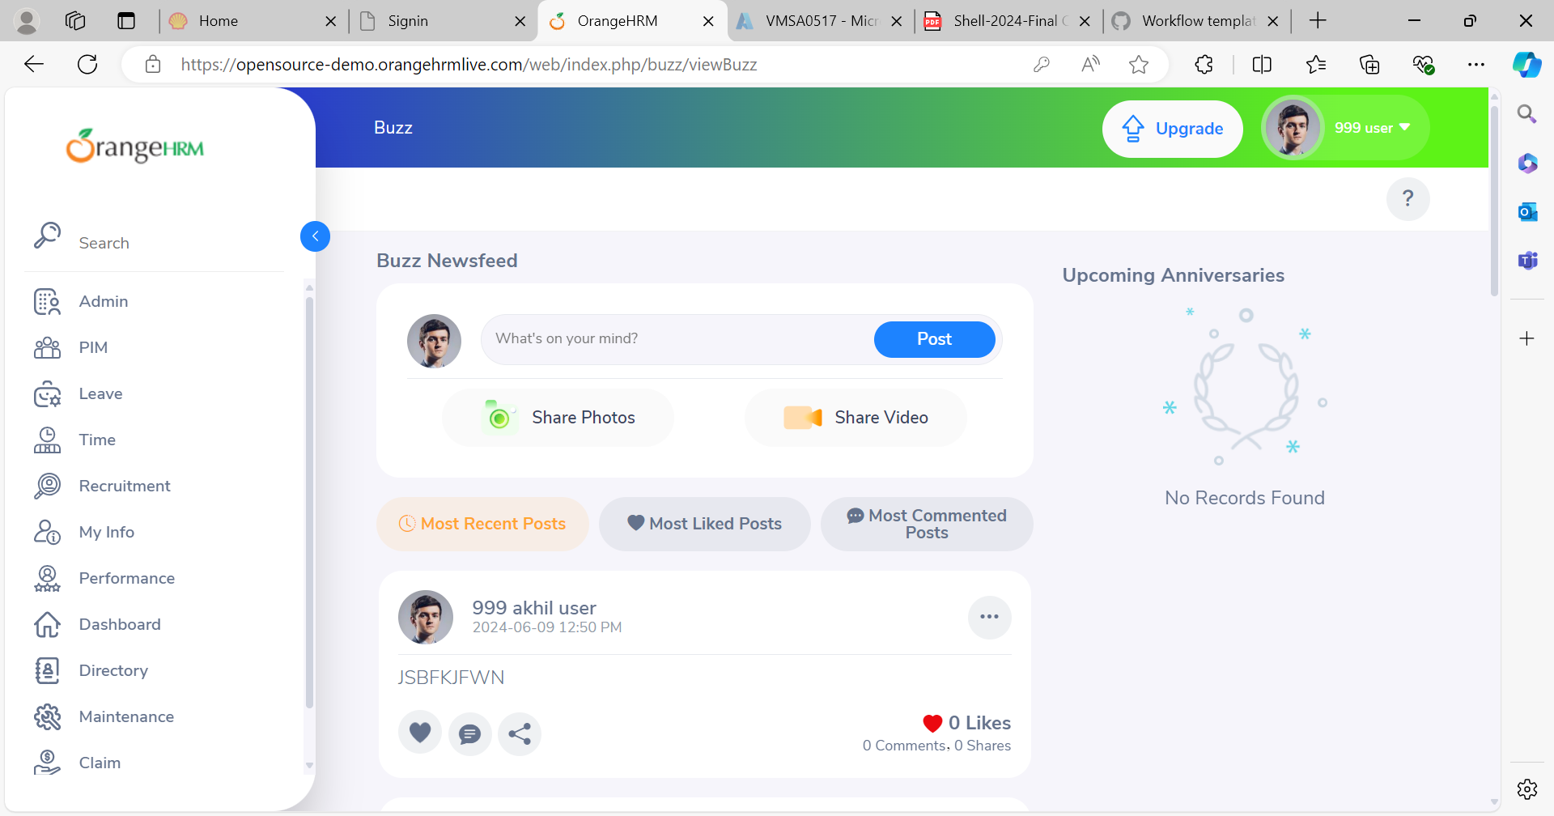

**Bug ID: BR-002**

**Title:** License Expiry Date Updates with Invalid Dates in ‘My Info’ Page

**Description**: When a user enters an invalid date for the License Expiry Date in the ‘Personal Details’ section of the ‘My Info’ page, the date is still accepted and saved without displaying a warning message. This issue allows invalid dates to be stored in the system.

**Steps to Reproduce:**

1. Navigate to the ‘My Info’ page from the sidebar.
2. Click on the ‘Personal Details’ option.
3. Enter an invalid date (e.g., 31/02/2024) in the License Expiry Date field.
4. Save the changes.

**Expected Result:**

* Only valid dates should be accepted and saved.
* A warning message should be displayed for invalid dates.

**Actual Result:**

* Invalid dates are accepted and saved without any warning message.

**Severity:** High

**Priority:** Medium

**Environment**:

* OS: Windows 10
* Browser: Google Chrome Version 92.0.4515.107
* Application Version: OrangeHRM 4.8

